**Ex. No. : 08 - A Date :**

**Register No. : 221701045 Name : RAHUL SANJAY J**



**Send SMS**

**Aim**

Develop an application to send SMS.

***Procedure:***

**Step 1 :** File → New Project  
 Provide the application name (e.g.,"SMS") and click “Next”.

**Step 2 :** Select the target Android devices  
 Select the minimum SDK to run the application. Click “Next”.

**Step 3 :** Choose the activity for the application  
 By default, choose “Blank Activity”. Click “Next”.

**Step 4 :** Enter activity name and click “Finish”.

**Step 5 :** Edit the program

Add SMS permissions (SEND_SMS) in the manifest file.

Use SMSMANAGER in MainActivity.kt to send messages from the app to a . provided phone number

**Step 6 :** Run the application  
 Two ways to run the application:

1. Running through emulator (with Sim Card Configured )  
   
 2. Running through mobile device

***AndroidManifest.xml***

**<?xml version="1.0" encoding="utf-8"?>**

**<manifest xmlns:android="http://schemas.android.com/apk/res/android"**

**package="com.example.sms">**

**<!-- Required permission for sending SMS -->**

**<uses-permission android:name="android.permission.SEND_SMS" />**

**<!-- Declare that the app uses telephony features but doesn't require them -->**

**<uses-feature**

**android:name="android.hardware.telephony"**

**android:required="false" />**

**<application**

**android:allowBackup="true"**

**android:icon="@mipmap/ic_launcher"**

**android:label="@string/app_name"**

**android:roundIcon="@mipmap/ic_launcher_round"**

**android:supportsRtl="true"**

**android:theme="@style/Theme.SMS">**

**<activity**

**android:name=".MainActivity"**

**android:exported="true">**

**<intent-filter>**

**<action android:name="android.intent.action.MAIN" />**

**<category android:name="android.intent.category.LAUNCHER" />**

**</intent-filter>**

**</activity>**

**</application>**

**</manifest>**

***Activity_main.xml***

**<?xml version="1.0" encoding="utf-8"?>**

**<androidx.constraintlayout.widget.ConstraintLayout xmlns:android="http://schemas.android.com/apk/res/android"**

**xmlns:app="http://schemas.android.com/apk/res-auto"**

**xmlns:tools="http://schemas.android.com/tools"**

**android:layout_width="match_parent"**

**android:layout_height="match_parent"**

**android:background="@color/white"**

**tools:context=".MainActivity">**

**<TextView**

**android:id="@+id/titleTextView"**

**android:layout_width="match_parent"**

**android:layout_height="wrap_content"**

**android:background="@color/purple_500"**

**android:padding="16dp"**

**android:text="Send SMS"**

**android:textColor="@color/white"**

**android:textSize="20sp"**

**android:textStyle="bold"**

**app:layout_constraintTop_toTopOf="parent" />**

**<EditText**

**android:id="@+id/phoneNumberEditText"**

**android:layout_width="match_parent"**

**android:layout_height="wrap_content"**

**android:layout_marginStart="16dp"**

**android:layout_marginTop="16dp"**

**android:layout_marginEnd="16dp"**

**android:background="@drawable/edit_text_background"**

**android:hint="Enter the phone number...!"**

**android:inputType="phone"**

**android:padding="12dp"**

**android:textSize="16sp"**

**app:layout_constraintTop_toBottomOf="@id/titleTextView" />**

**<EditText**

**android:id="@+id/messageEditText"**

**android:layout_width="match_parent"**

**android:layout_height="wrap_content"**

**android:layout_marginStart="16dp"**

**android:layout_marginTop="16dp"**

**android:layout_marginEnd="16dp"**

**android:background="@drawable/edit_text_background"**

**android:hint="Enter the message...!"**

**android:inputType="textMultiLine"**

**android:minLines="3"**

**android:padding="12dp"**

**android:textSize="16sp"**

**app:layout_constraintTop_toBottomOf="@id/phoneNumberEditText" />**

**<Button**

**android:id="@+id/sendButton"**

**android:layout_width="match_parent"**

**android:layout_height="wrap_content"**

**android:layout_marginStart="16dp"**

**android:layout_marginTop="16dp"**

**android:layout_marginEnd="16dp"**

**android:background="@drawable/button_background"**

**android:padding="12dp"**

**android:text="Send"**

**android:textColor="@color/white"**

**android:textSize="16sp"**

**app:layout_constraintTop_toBottomOf="@id/messageEditText" />**

**</androidx.constraintlayout.widget.ConstraintLayout>**

***MainActivity.kt***

**package com.example.sms**

**import android.Manifest**

**import android.content.pm.PackageManager**

**import android.os.Build**

**import android.os.Bundle**

**import android.telephony.SmsManager**

**import android.widget.Button**

**import android.widget.EditText**

**import android.widget.Toast**

**import androidx.appcompat.app.AlertDialog**

**import android.appcompat.app.AppCompatActivity**

**import android.core.app.ActivityCompat**

**import androidx.core.content.ContextCompat**

**class MainActivity : AppCompatActivity() {**

**private lateinit var phoneNumberEditText: EditText**

**private lateinit var messageEditText: EditText**

**private lateinit var sendButton: Button**

**private val SMS_PERMISSION_CODE = 100**

**override fun onCreate(savedInstanceState: Bundle?) {**

**super.onCreate(savedInstanceState)**

**setContentView(R.layout.activity_main)**

**// Initialize views**

**phoneNumberEditText = findViewById(R.id.phoneNumberEditText)**

**messageEditText = findViewById(R.id.messageEditText)**

**sendButton = findViewById(R.id.sendButton)**

**// Set click listener for the send button**

**sendButton.setOnClickListener {**

**if (checkSmsPermission()) {**

**sendSMS()**

**} else {**

**requestSmsPermission()**

**}**

**}**

**}**

**private fun checkSmsPermission(): Boolean {**

**return ContextCompat.checkSelfPermission(**

**this,**

**Manifest.permission.SEND_SMS**

**) == PackageManager.PERMISSION_GRANTED**

**}**

**private fun requestSmsPermission() {**

**if (ActivityCompat.shouldShowRequestPermissionRationale(**

**this,**

**Manifest.permission.SEND_SMS**

**)**

**) {**

**// Show custom dialog explaining why we need this permission**

**AlertDialog.Builder(this)**

**.setTitle("Permission needed")**

**.setMessage("Allow Send SMS to send and view SMS messages?")**

**.setPositiveButton("ALLOW") { _, _ ->**

**ActivityCompat.requestPermissions(**

**this,**

**arrayOf(Manifest.permission.SEND_SMS),**

**SMS_PERMISSION_CODE**

**)**

**}**

**.setNegativeButton("DENY") { dialog, _ ->**

**dialog.dismiss()**

**}**

**.create()**

**.show()**

**} else {**

**// Request permission directly**

**ActivityCompat.requestPermissions(**

**this,**

**arrayOf(Manifest.permission.SEND_SMS),**

**SMS_PERMISSION_CODE**

**)**

**}**

**}**

**override fun onRequestPermissionsResult(**

**requestCode: Int,**

**permissions: Array<out String>,**

**grantResults: IntArray**

**) {**

**super.onRequestPermissionsResult(requestCode, permissions, grantResults)**

**if (requestCode == SMS_PERMISSION_CODE) {**

**if (grantResults.isNotEmpty() && grantResults[0] == PackageManager.PERMISSION_GRANTED) {**

**// Permission granted, send the SMS**

**sendSMS()**

**} else {**

**// Permission denied**

**Toast.makeText(**

**this,**

**"SMS permission denied. Cannot send messages.",**

**Toast.LENGTH_SHORT**

**).show()**

**}**

**}**

**}**

**private fun sendSMS() {**

**val phoneNumber = phoneNumberEditText.text.toString().trim()**

**val message = messageEditText.text.toString().trim()**

**if (phoneNumber.isEmpty() || message.isEmpty()) {**

**Toast.makeText(this, "Please enter both phone number and message", Toast.LENGTH_SHORT).show()**

**return**

**}**

**try {**

**val smsManager = if (Build.VERSION.SDK_INT >= Build.VERSION_CODES.S) {**

**this.getSystemService(SmsManager::class.java)**

**} else {**

**@Suppress("DEPRECATION")**

**SmsManager.getDefault()**

**}**

**smsManager.sendTextMessage(phoneNumber, null, message, null, null)**

**Toast.makeText(this, "Message Sent", Toast.LENGTH_SHORT).show()**

**// Clear fields after sending**

**messageEditText.text.clear()**

**} catch (e: Exception) {**

**Toast.makeText(this, "Failed to send SMS: ${e.message}", Toast.LENGTH_SHORT).show()**

**e.printStackTrace()**

**}**

**}**

**}**

***Output***

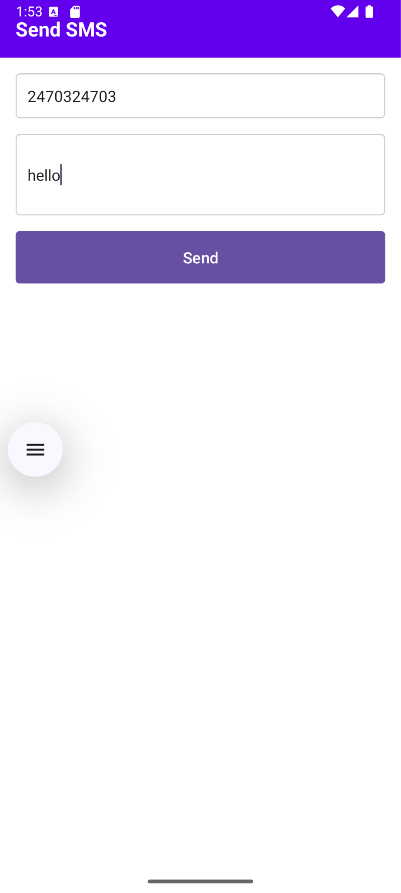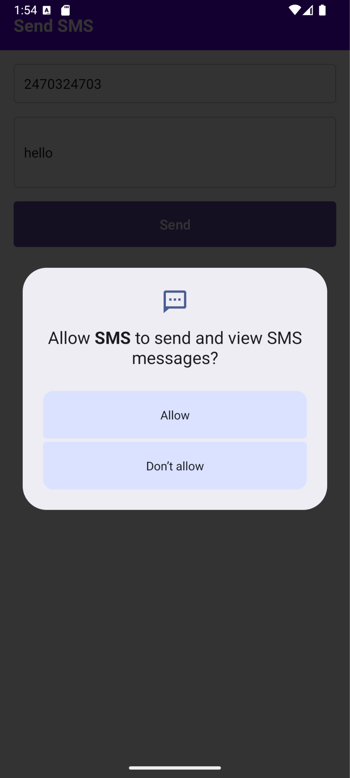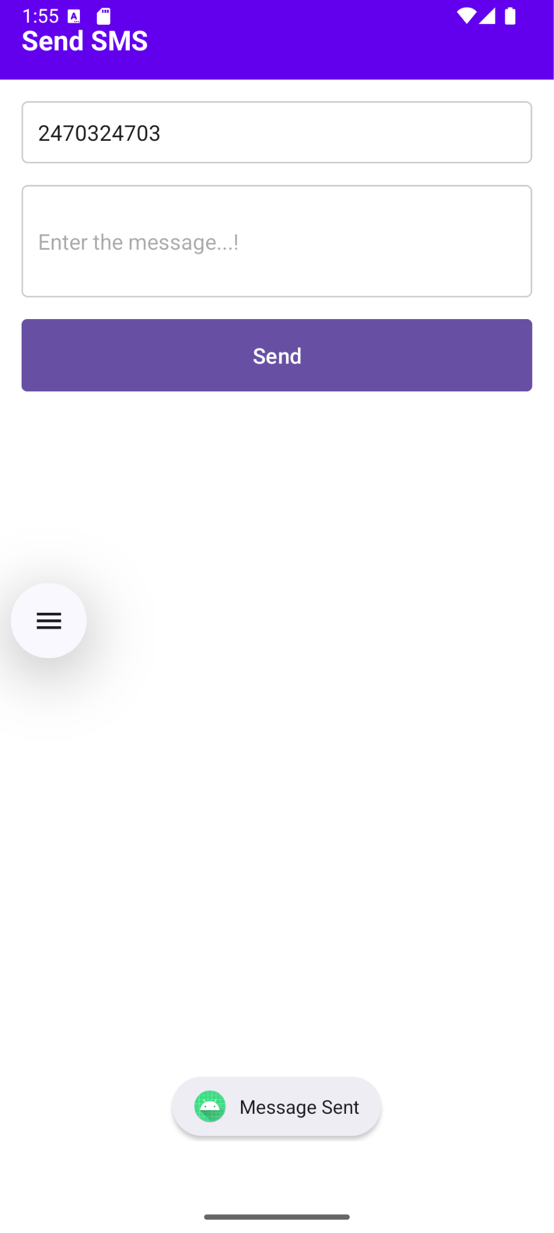

**Result:**

The SMS application successfully sends text messages to specified phone numbers using Kotlin code on a mobile device with SMS permission granted.